**LESSON 4: SEMICONDUCTORS**

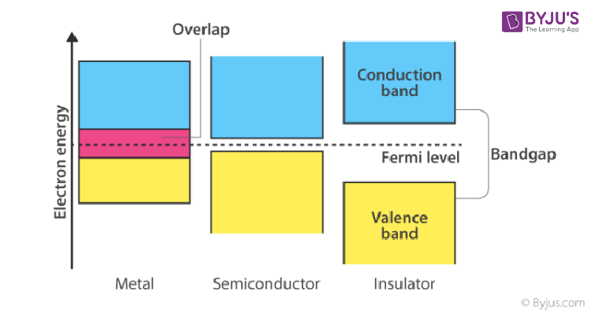

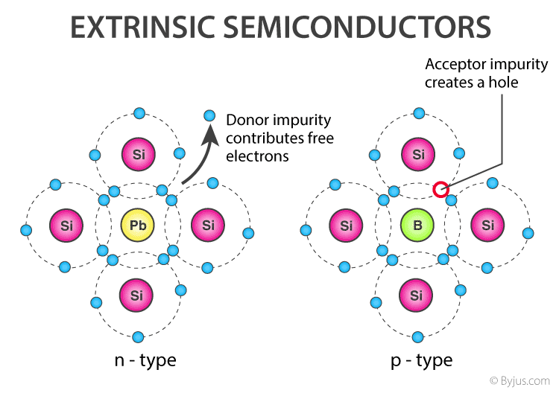

| **Property** | **Intrinsic Semiconductor** | **Extrinsic Semiconductor** |
| --- | --- | --- |
| **Definition** | Pure semiconductor material with no impurities. | Semiconductor material doped with impurities to enhance conductivity. |
| **Examples** | Pure silicon (Si), pure germanium (Ge). | Doped silicon or germanium (e.g., Si with phosphorus or boron). |
| **Conductivity** | Low, due to the limited number of charge carriers (electrons and holes). | Higher, due to the added charge carriers from doping. |
| **Charge Carriers** | Electrons and holes are equal in number. | Depends on the type of doping: electrons in n-type, holes in p-type. |
| **Doping** | No doping; pure material. | Doped with trivalent (p-type) or pentavalent (n-type) impurities. |
| **Examples of Dopants** | None (pure material). | - **n-type**: Phosphorus (P), Arsenic (As).  - **p-type**: Boron (B), Gallium (Ga). |
| **Carrier Concentration** | Determined by temperature and intrinsic properties of the material. | Determined by the concentration and type of dopants. |

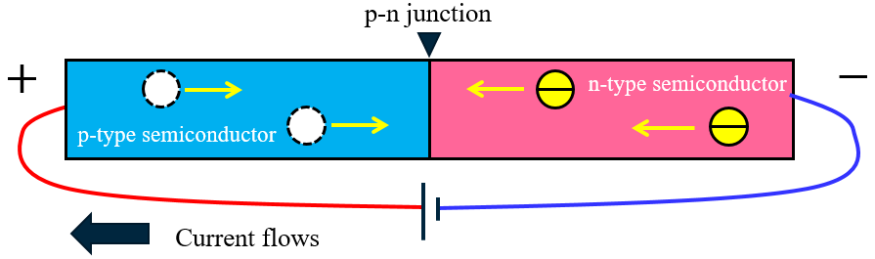

REVERSED BIASED

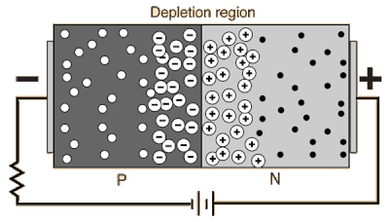

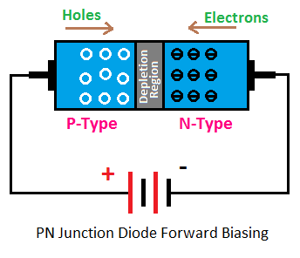 FORWARD BIASED